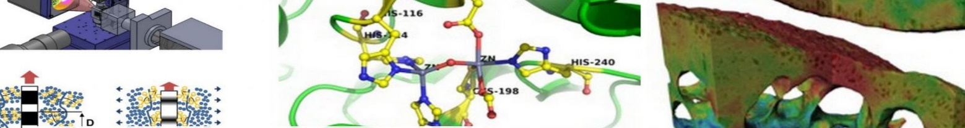
ImagingBioPro Network
Online Educational Materials (OEM) Funding Application

Details of applicant:
Title: |  | First name: |  |  | Surname:
Email:
Division / Department:
Organisation:

Details of the Online Educational Materials (1 page maximum)
Purpose of the OEM
Beneficiaries/audience (e.g. PhD students in bioengineering)¹
Fit to ImagingBioPro Network²
Funding requested³

1. ImagingBioPro Network is committed to developing and using platforms that disseminate data openly and freely. The published OEM and its affiliated resources should be in the public domain (e.g., open access and open source). The OEM and a short description are required to be put on the IBP network website.
2. The OEM should acknowledge the UKRI-funded ImagingBioPro network (MR/R025673/1).
3. Approx. £500 for every 15 minutes animated videos or for every 60 minutes non-animated videos. Payment is processed upon reception of the OEM.

